Local Activities for Under 5s - South & West Oxford, Botley, North Hinksey, Cumnor and Appleton
Day | Time | Activity | Contact
Monday | 9.30-12  10-11am  10 onwards  1-3pm  2pm | South Oxford Family Room, Stay and Play, Whitehouse Road, Oxford  Little Fishes, Baby and Toddler Group, St Andrews Church, Dean Court  Monkey Music, West Oxford Community Centre, Botley Road  Stay and Play at Botley Bridges, Elms Road, Oxford, OX2 9JS  Baby College. Baby Massage at West Oxford Community Centre, Botley Road | 01865 254875  01865 862557  01235 519806  07498563636  01865 421879
Tuesday | 10-12  9.30-11  9.45 onwards  10-12  11-11.30  3.30 onwards | South Oxford Family Room – Breastfeeding Support (OBS) & Well Baby Clinic  Toddler Group at SS Peter & Paul Church Hall, Botley  Baby College Class at West Oxford Community Centre, Botley Road  Family Fun, Kings Centre, Osney Mead, Oxford  Rhyme time at Botley Library, Elms Court. 1st & 3rd Tuesday of the month  Sing and Sign, Dean Court Community Centre, Oxford  Betty Bloom Dance Classes, Seacourt Hall, Oxford | 01865 254875  0800236346  01865 421879  01865 297400  01865 248142  07795005832  07785 232862
Wednesday | 9-11  9.30  10-12  9.30 onwards  10.30-11.30  1-2.30 | Toddler Group at St Michael’s Church, Parish Centre, Cumnor  Saltbox Music at Dean Court Community Centre, Oxford  Sparklers Toddler Group at St Ebbes Church  Tumbletots, SS Peter & Paul Church Hall, Botley  Happy Faces Aloud, West Oxford Community Centre, Botley Road  Well Baby Clinic at Botley Bridges, Elms Road, Oxford, OX2 9JS | 01865864397  01993 704207  01865 240438  01235 520373  01865 421879  07498563636
Thursday | 9.30-11  9.45 | Toddler Group at SS Peter & Paul Church Hall, Botley  Baby Ballet at Dean Court Community Centre, Oxford | 0800236346  01422 329471
Friday | 9-11.30  9.30-12  9.15  9.30-11.15  9.30-11.30  9.30-10  1.15-3 | Botley Bridges, Stay, Play & Learn, Elms Road, Oxford, OX2 9JS  South Oxford Family Room, Stay and Play, Whitehouse Road, Oxford  Baby College, Dean Court Community Centre, Dean Court  Toddler Group at West Oxford Community Centre, Botley Road  Appleton Toddlers at Appleton Village Hall,  Hilary’s Music at West Oxford Community Centre, Botley Road  Baby Stay, Play & Learn at Botley Bridges, Elms Road, OX2 9JS | 07498563636  01865 254875  01865 421879  01865 245761  01865 863519  01865 245761  07498563636
Saturday | 10-12  10-12  9.30 onwards | Saturdads at Botley Bridges, Elms Road, Oxford – 1st Saturday of the month  Saturdads at South Oxford Family Room, Whitehouse Road, Oxford  French Club, Rosary Rooms, Yarnells Hill, Oxford (every other Saturday) | 07498563636  01865 254875  07753344288
Sunday | 9.30-12  11-11.45 | Community Breakfast at Dean Court Community Centre – last Sunday of month  Football for boys and girls under 5, Lois Memorial Playing Field | 07900831832

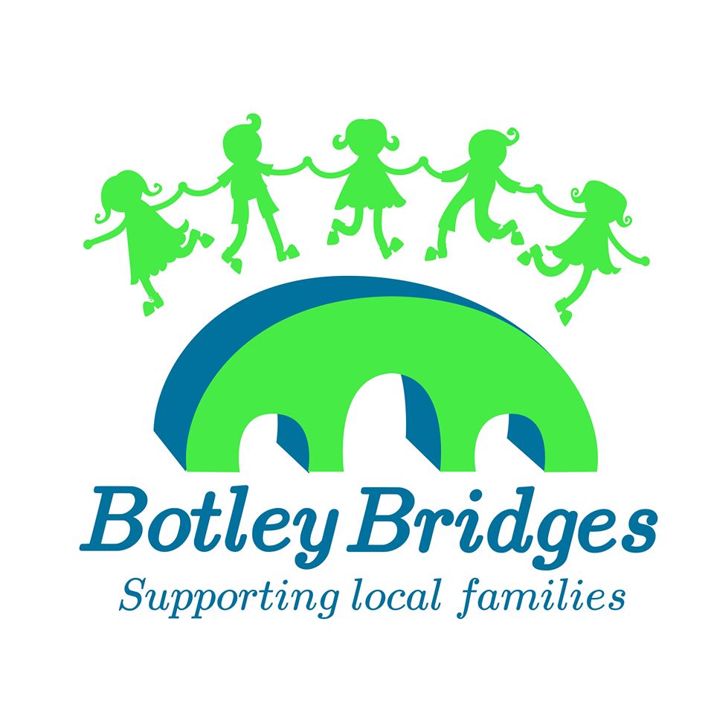 All groups correct when going to print, but please do check times with individual groups to avoid disappointment

List devised by Botley Bridges – July 2019

