Form for Requesting a Free Christmas Hamper 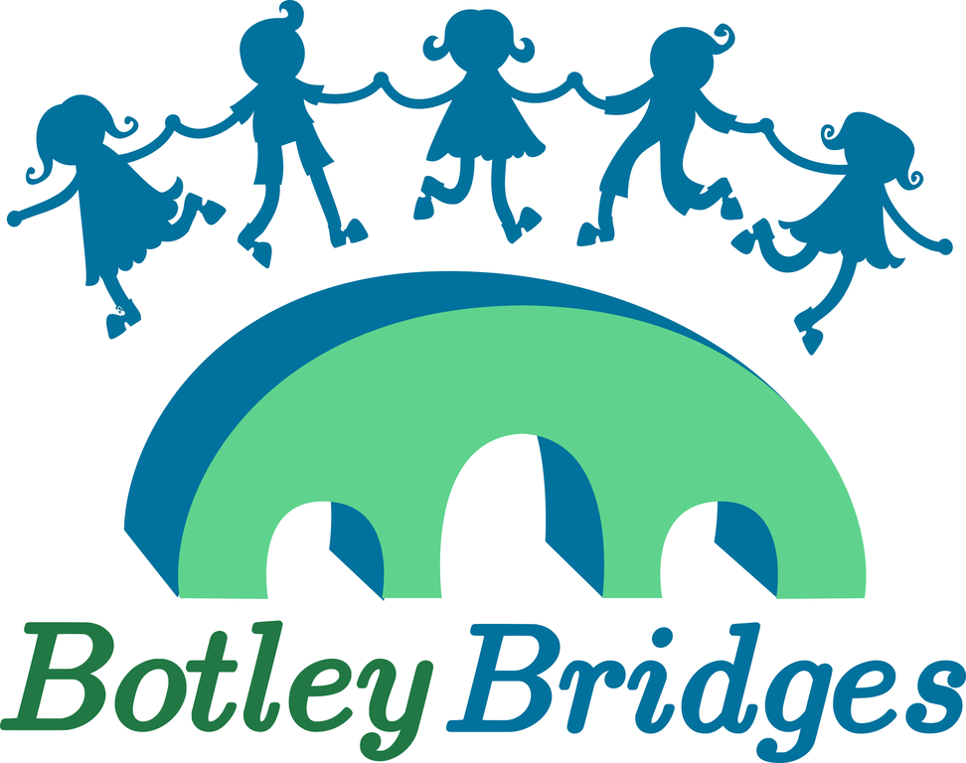
With Christmas coming up we know that this has been a difficult year for many households.
Botley Bridges in collaboration with the Community Larder and Food for Charities are inviting any families on a low income who live in Botley, North Hinksey, Cumnor and the West Oxford area to complete a request form so we can arrange for a lovely Christmas hamper to be ready for you to collect from St Peter and St Paul Church Hall, OX2 9JN, Botley on Wednesday 22nd December
The hampers will contain dried food, some fresh food, Christmas treats and some toys.
If you are unable to collect we can deliver (please make a note on the form below). We are asking for specific details about your household so we can arrange the most suitable hamper for you all. After 22nd December the information will be deleted in accordance with GDPR.
1 | First Name
2 | Surname
3. | Address and post code
4 | Contact number
5 | Number of adults in the household
6 | Number of children in the household- please add ages and gender (for gifts)
7 | Any specific food requirements – linked to allergies etc
8 | Can you pick up the hamper on 22nd December from St Peter and St Pauls Church Hall in Botley from 12.00 midday | Yes or No.  If no we will contact you to arrange delivery
9. | Any other comment – for example are you completing this form for someone else

Completed forms can be downloaded from the Botley Bridges website www.botleybridges.org and e-mailed to sue@botleybridges.org or handed in to the school or pre-school your children attend if:
West Oxford Primary, Cumnor Primary, North Hinksey Primary or Botley Primary, Cumnor pre-school or North Hinksey pre-school.
You can also register online for a hamper at: https://forms.gle/fJ7qEn4ifBsPSFfN9

Hampers are being funded by the The Community Larder, Food for Charities, private donations and the local community.

