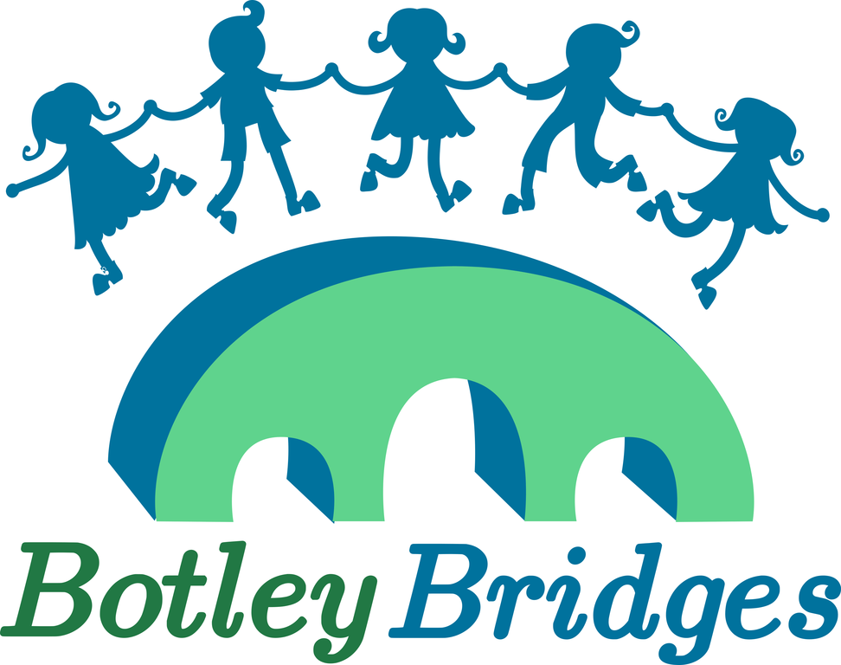
Form for Requesting a Free Christmas Hamper
With Christmas coming up we know that this has been a difficult year for many households.
Botley Bridges in collaboration with local food charities are inviting any families on a low income who live in Botley, North Hinksey, Cumnor and the West Oxford area to request a lovely Christmas hamper (exact areas covered can be found here https://tinyurl.com/4t2haw6h). These will be ready for you to collect from St Peter and St Paul Church Hall, OX2 9JN, Botley on Wednesday 20th or Thursday 21st December.
The hampers will contain dried food, some fresh food, Christmas treats and some toys.
If you are unable to collect we can deliver (please make a note on the form below). We are asking for specific details about your household so we can arrange the most suitable hamper for you all. Most information will be deleted in accordance with GDPR within one month of collection/delivery. We may keep postcodes on record for up to one year to support grant applications to local organisations.
1 | First Name
2 | Surname
3. | Address
4. | Post Code
5. | Contact number
6. | Email Address
7. | Number of adults in the household
8. | Gender of adults (so we can try to match appropriate gifts)
9. | Number of children in the household
10. | Ages and genders of the children (so we can try to match appropriate gifts)
11. | Any specific food requirements – linked to allergies etc
12. | Can you pick up the hamper on Wed 20th Dec 2pm-7pm or Thurs 21st Dec 9am-12pm from St Peter and St Pauls Church Hall in Botley? | Yes - Wed 20th, 2pm-7pm  Yes - Thurs 21st, 9am-12pm  No  If no we will contact you to arrange delivery on either Wed 20th or Thurs 21st
13. | Do you use City Larder and if so, would you prefer to collect from there on the usual larder day? | Yes - I’ll collect from City Larder on Fri 22nd Dec  No
14. | Any other comment – for example are you completing this form for someone else
15. | Please let us know of any particular likes/dislikes your children have to help us select appropriate gifts. We can offer no guarantees as we are dependent on the donations we receive but any information we have can be useful.

This form can be downloaded from the Botley Bridges website www.botleybridges.org and e-mailed to sue@botleybridges.org or handed in to the school or pre-school your children attend if they are at:
West Oxford Primary, Cumnor Primary, North Hinksey Primary or Botley Primary, Cumnor pre-school or North Hinksey pre-school.
You can also register online for a hamper at: https://botley-hampers.web.app
Hampers are being funded by private donations, the local community and local food charities.

